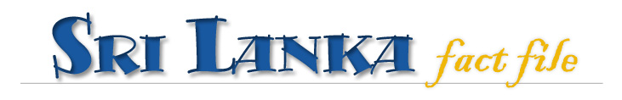
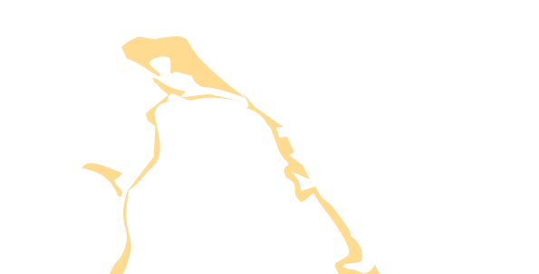
Called “the finest island of its size in the world…” by Marco Polo, teardrop-shaped
Sri Lanka nestles at the foot of India, in the balmy, blue-green waters of the Indian Ocean.

Facts & Figures

-
Official NameDemocratic Socialist Republic of Sri Lanka-
National Holiday Independence Day, 04 February (1948)-
Size 65525 sq km-
Geographic Coordinates 6-10 N, 80-82 E-
LocationIsland off the Southeastern shores of India, 800km north of equator-
Coastline 1340 km-
CapitalSri Jayewardenepura Kotte-
Commercial capitalColombo-
Population (May 2005)20 million-
LanguagesSinhala, Tamil & English. English is widely spoken throughout Sri Lanka, with the exception of remote villages.-
Ethnic MixMajority are Sinhalese, minorities Tamil & Moor-
Religionsmostly Buddhist, then Hindu, Christian & Muslim-
Major ExportsTextiles & garments, tea, diamonds, gems, rubber & coconut products-
Highest peakPidurutalagala (Mt. Pedro) At 2524m, Adam’s peak (Sri Pada), holy to believers of all religions, ranks 4th at 2,243m.

Essentials

-
Time ZoneFive and a half hours ahead of Greenwich Mean Time (GMT+5 ½). Daylight Saving Time is not observed.-
Voltage requirement230/240 volts AC, 50Hz. Round tree-pin plugs are usual, with bayonet lamp fittings.-
Currency Sri Lanka Rupee (Rs). 100 cents = 1 Rs.-
Travelers Chequeswidely accepted in banks and money exchanges, a 1% stamp duty is payable, plus a small commission.-
Credit CardsIncreasingly accepted in the main areas, but don’t expect your local shop keeper to take one.
ATMs: Common in larger towns.
Tipping: A service charge of 10% is added to all restaurant and hotel bills. A small tip (no more than 10%) above this is appreciated.
Drivers expect a tip if you’ve bargained well.
-
ATMscommon in larger towns-
TippingA service charge of 10% is added to all restaurant & hotel bills. A small tip (no more than 10%) above this is appreciated. Drivers expect a tip if you’ve bargained well.-
Working weekMonday to Friday-
Medical FacilitiesThe professional standards of doctors and surgeons are excellent with specialist, hospitals including Eye, Children’s, Ayurvedic and Maternity. For emergencies
call:
Fire and Ambulance
Tel: 2422222 Police Tel: 2433333.
Tuk-tuk and taxi drivers will know of the nearest hospital.
-
GSM Network900

- Official Name | Democratic Socialist Republic of Sri Lanka
- National Holiday | Independence Day, 04 February (1948)
- Size | 6510 sq km
- Geographic Coordinates | 6-10 N, 80-82 E
- Location | Island off the Southeastern shores of India, 800km north of equator
- Coastline | 1340 km
- Capital | Sri Jayewardenepura Kotte
- Commercial capital | Colombo
- Population (May 2005) | 20 million
- Languages | Sinhala, Tamil & English. English is widely spoken throughout Sri Lanka, with the exception of remote villages.
- Ethnic Mix | Majority are Sinhalese, minorities Tamil & Moor
- Religions | mostly Buddhist, then Hindu, Christian & Muslim
- Major Exports | Textiles & garments, tea, diamonds, gems, rubber & coconut products
- Highest peak | Pidurutalagala (Mt. Pedro) At 2524m, Adam’s peak (Sri Pada), holy to believers of all religions, ranks 4th at 2243m
-
-
-
-

Transport

-
TaxiRadio cars can be called by telephone and are very good value. The minimum charge is Rs30 per kilometer. Other taxis are available, but are not metered, so it is wise to agree on the fare. Cabs from the airport taxi counter at Bandaranaike International Airport cost from Rs 1,000 – 1,500 for the journey into Colombo.
Other taxi counters may charge more. Always ask.-
Hire Cars Self-drive hire cars are readily available, but if it’s your first time here, consider hiring a car and driver from the counters at the airport or from your hotel.
Drivers offer excellent insight into the island and great flexibility, staying in dedicated drivers’ rooms at the same hotel(s) as you.-
Tuk-tuksYou’ve not been to Sri Lanka if you’ve not travelled in a tuk-tuk. Rs20-30 per km. Bargain for the best prices.-
TrainsMany places of interest are served by trains from Colombo Fort station.-
BusesA comprehensive network covering the island with express services between principal towns. Can get crowded.

